**Interconnections – Staying connected by technology**

**Brainstorm – ways we communicate via technology:**

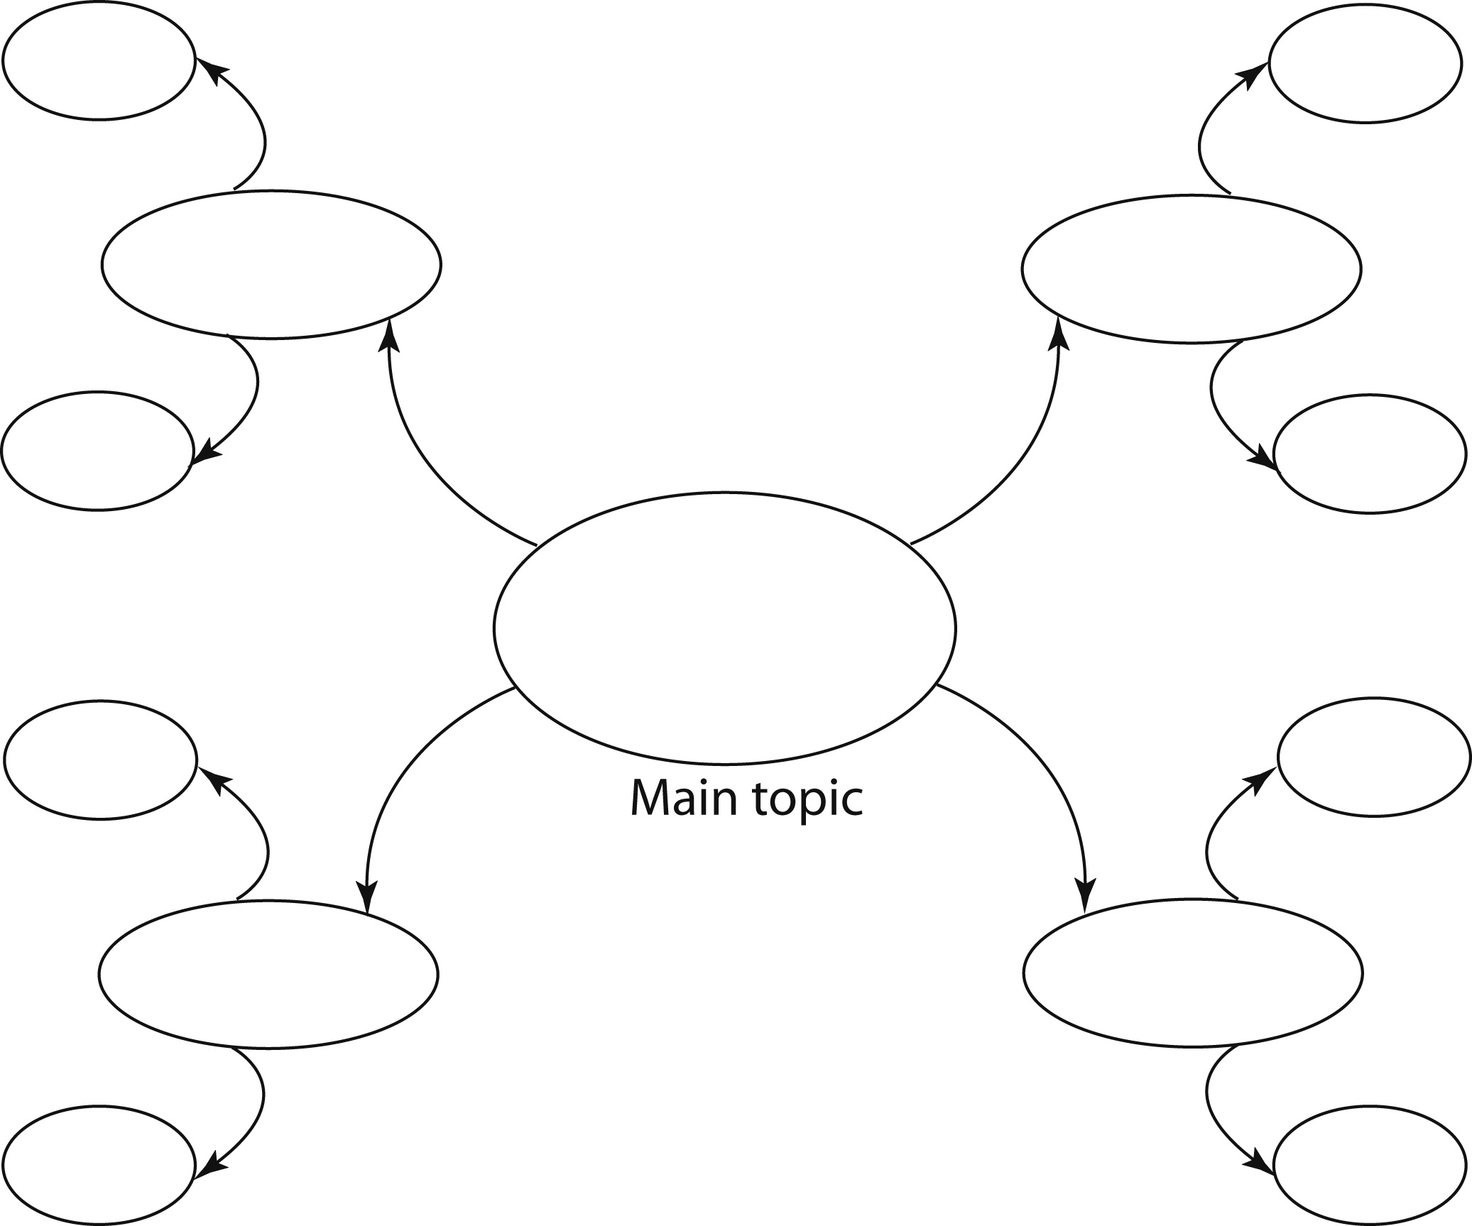

**Telephone traffic: examine the map of telephone traffic and answer the following questions.**

1. **Identify the three countries with the highest volumes of telephone traffic.**
2. **Which countries does Australia have direct connections with?**
3. **List the major connections for the following continents: Asia, Europe, Nth America Africa and Australia. i.e who do they connect with?**

**Internet: The internet began life in a US Government Defence research lab in California in the late 1960’s. The first computers in Australia exchanged files using dial up. Today internet growth has increased dramatically around the world.**

1. **List 4 ways we use the internet to communicate**

**-**

**-**

**-**

**-**

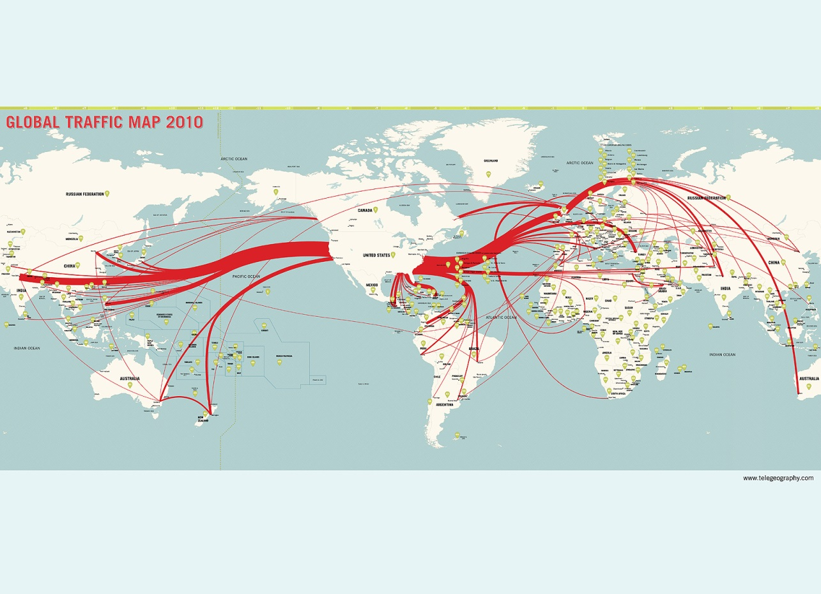

**5. What patterns can you see in the global internet traffic map? Is it similar to the telephone traffic?**

**6. In which countries do you see the highest level of connections? Why do you think this is the case?**